Name: Ranjitha. R Reg NO: 192421285
Experiment 2: Sketch a Simple Prototype of a Bus Ticket Booking System Using Figma Aim
To design a simple prototype of a Bus Ticket Booking System using Figma, allowing users to search for buses, select seats, and confirm their bookings.

Procedure

- Open the Figma website and log in to your account.

- Create a new design file.

- Use the Frame tool (F) to create a mobile screen.

- Design the Home Screen with source, destination, journey date, and a Search Buses button.
- Create a Bus Search Results screen displaying bus names, departure times, and ticket prices.
- Design a Seat Selection screen with available, booked, and selected seats.

- Create a Booking Confirmation screen showing the booking ID, journey details, seat number, and fare.
- Use the Text and Rectangle tools to add labels, buttons, and input fields.

- Open the Prototype tab and connect the screens using interactive buttons.

- Click Present to test the prototype and verify the navigation between screens.

Output

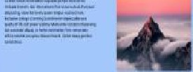
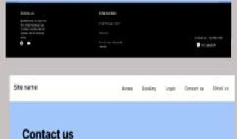
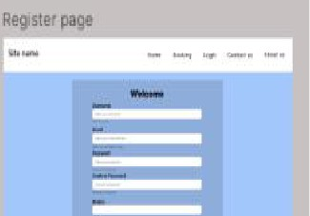
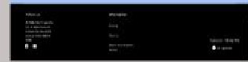
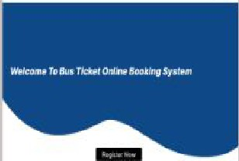
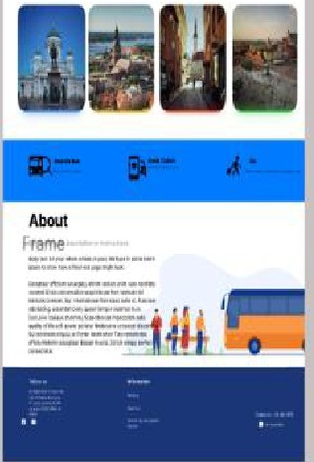
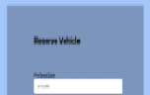
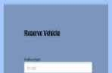
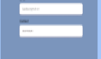
tu
Allaul
- =
1st00m
-
l!I
,--
,-
'
'
-�-
II II
II II
Ell II
EIEI II
£11 II
El13 II
£113 II
£113111
-�-
II II
II II
HI II
113 II
II II
113 II
1£1 II
1£1111
-
•

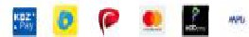




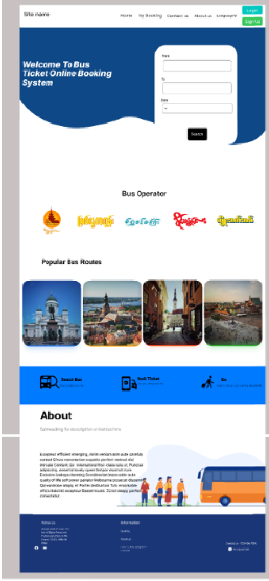
Log n mer --.
-
Adm n Login
-
.,...,.,

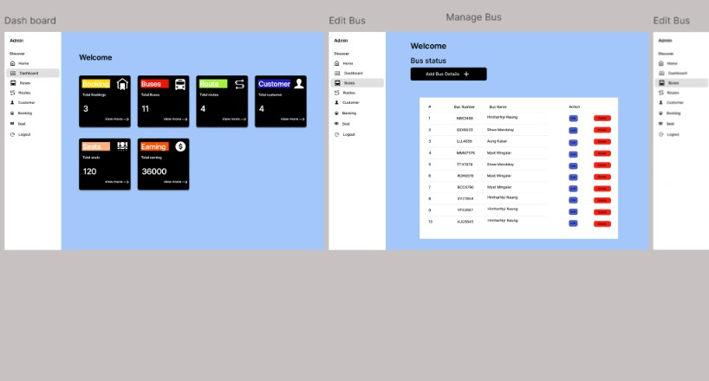
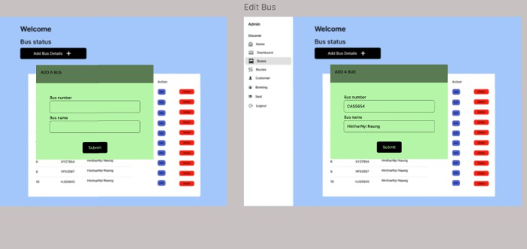
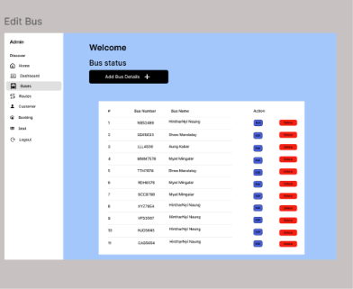

Result

A simple Bus Ticket Booking System prototype was designed successfully using Figma. The prototype demonstrates bus searching, seat selection, and booking confirmation through interactive screens.

